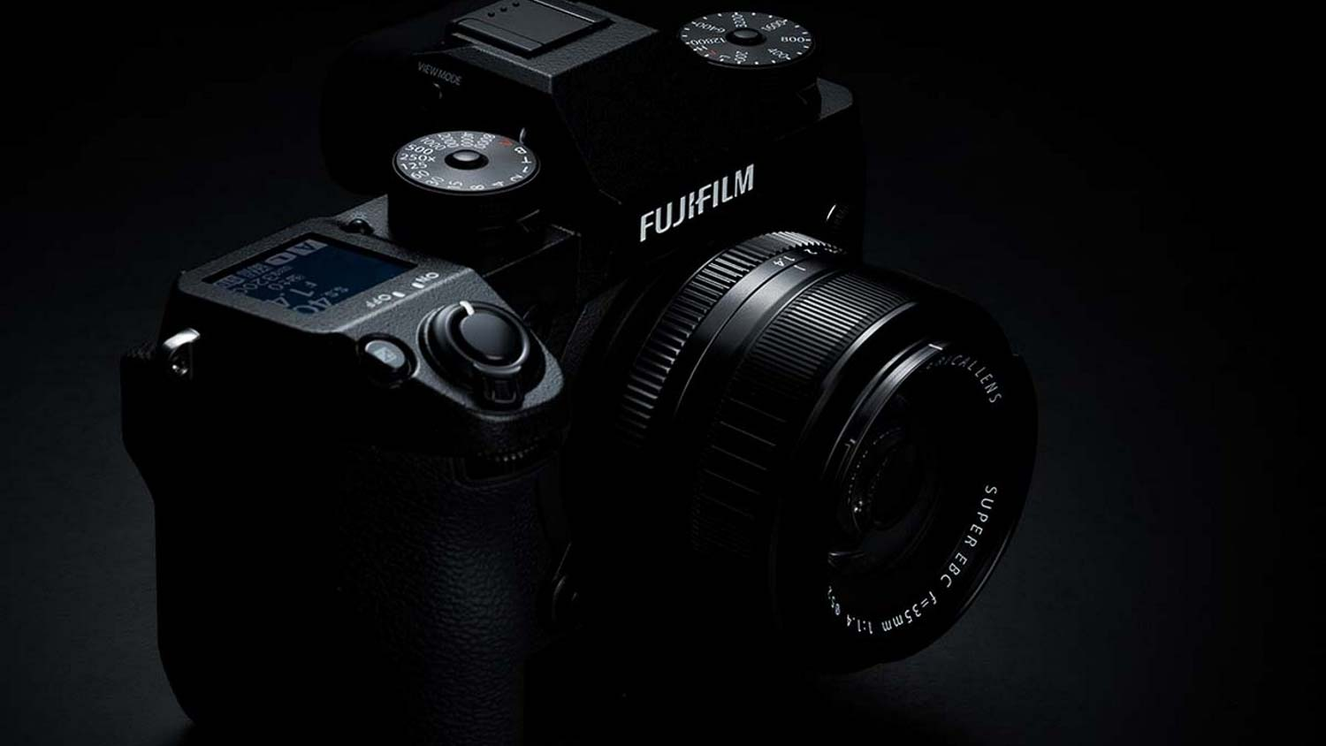

FUJIFILM X-H2S

Professional Camera Details & Features

Introduction
The Fujifilm X-H2S is one of Fujifilm's most advanced mirrorless cameras, designed for professional photographers and videographers. It combines a powerful image sensor, high-speed performance, excellent autofocus, and professional-grade video capabilities in a durable and weather-resistant body. This camera is ideal for wildlife, sports, action, wedding, documentary, and commercial photography.

Key Specifications
Specification | Details
Camera Type | Mirrorless Digital Camera
Sensor | 26.1 MP APS-C X-Trans CMOS 5 HS (Stacked Sensor)
Image Processor | X-Processor 5
Lens Mount | Fujifilm X Mount
ISO Range | 160 – 12,800 (Expandable: 80 – 51,200)
Continuous Shooting | Up to 40 fps (Electronic Shutter)
Image Stabilization | 5-Axis In-Body Image Stabilization (IBIS)
Video Recording | 6.2K 30fps, 4K 120fps, Full HD 240fps
Viewfinder | 5.76 Million-dot OLED EVF
LCD Screen | 3-inch Vari-Angle Touchscreen
Storage | CFexpress Type-B + SD UHS-II Dual Card Slots
Battery | NP-W235 Rechargeable Battery

Main Features

1. 26.1MP Stacked APS-C Sensor
The stacked sensor delivers incredibly fast image processing, outstanding image quality, and minimal rolling shutter, making it ideal for action photography.

2. X-Processor 5
The latest image processor provides faster autofocus, improved noise reduction, better color reproduction, and efficient power management.

3. Ultra-Fast Continuous Shooting
Capture up to 40 frames per second using the electronic shutter, making it perfect for wildlife, sports, and fast-moving subjects.

4. Professional Autofocus
Advanced AI-based autofocus detects:
- Human Faces
- Eyes
- Animals
- Birds
- Cars
- Motorcycles
- Airplanes
- Trains
It keeps moving subjects sharp even at high shooting speeds.

5. 5-Axis Image Stabilization
The built-in stabilization system provides up to 7 stops of shake reduction, allowing sharp handheld photos and smooth video recording.

6. Professional Video Recording
The X-H2S is a powerful hybrid camera capable of recording:
- 6.2K Video
- 4K at 120fps
- Full HD at 240fps
- 10-bit Internal Recording
- Apple ProRes Recording
- F-Log2 Support
- External RAW Output
These features make it suitable for filmmaking and professional content creation.

7. High-Quality Electronic Viewfinder
The 5.76-million-dot OLED EVF provides a bright, sharp, and accurate preview of the scene.

8. Fully Articulating LCD
The flip-out touchscreen makes shooting from high, low, or front-facing angles easy for photography, vlogging, and filmmaking.

9. Weather-Resistant Body
The magnesium alloy body is dust-resistant, splash-resistant, and designed to operate in temperatures as low as −10°C, making it reliable in harsh environments.

10. Dual Memory Card Slots
Supports:
- CFexpress Type-B
- SD UHS-II
This provides fast data writing, backup recording, and extended storage.

Advantages
- Excellent image quality
- Extremely fast autofocus
- 40fps burst shooting
- Professional 6.2K video recording
- Built-in image stabilization
- Rugged weather-sealed body
- Long battery performance
- AI subject detection
- Dual card slots
- Compact mirrorless design

Best For
- Wildlife Photography
- Sports Photography
- Wedding Photography
- Event Photography
- Travel Photography
- Documentary Work
- YouTube Content Creation
- Professional Videography
- Commercial Photography

Package Includes
- Fujifilm X-H2S Camera Body
- NP-W235 Battery
- Battery Charger
- USB-C Cable
- Shoulder Strap
- Body Cap
- User Manual

